Types of Object Complement
# Source: AI Source: Provided by: [Data Path: Persons Table -> ID Column: 1, Name_En Column: Motasem Essam] -> From: [ChatGPT] on [8/4/2025]
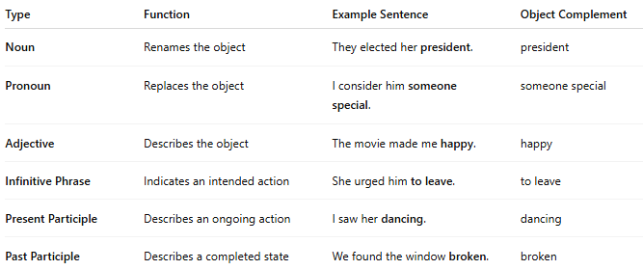

Type | Function | Example Sentence | Object Complement
Noun | Renames the object | They elected her president. | president
Pronoun | Replaces the object | I consider him someone special. | someone special
Adjective | Describes the object | The movie made me happy. | happy
Infinitive Phrase | Indicates an intended action | She urged him to leave. | to leave
Present Participle | Describes an ongoing action | I saw her dancing. | dancing
Past Participle | Describes a completed state | We found the window broken. | broken

